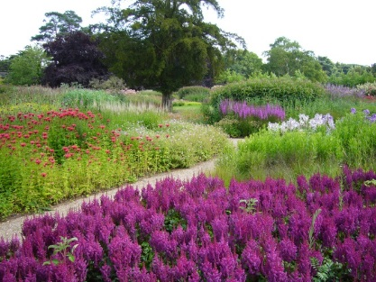
TRENTHAM GARDENS

APPLICATION FOR MEMBERSHIP 2020

Please either print and fill this form, or download the Word document, edit it, print and sign it, and post with your remittance, or scan and email, indicating you have made a BACS payment to:

Membership Secretary, Staffordshire Gardens and Parks Trust,
Cloister House, Blithfield, Admaston, Rugeley,WS15 3NL
Email: hyde.john@gmail.com

BACs payments quoting your initials and surname to:
Account name: Staffordshire Gardens and Parks Trust Company Ltd
Sort Code: 40-52-40
Account No: 00012318
Cheques should be made payable to: Staffordshire Gardens and Parks Trust
I/we wish to join Staffordshire Gardens and Parks Trust as (please tick as appropriate) and enclose a cheque for £………

Alternatively, I have made a BACS payment of £……..

Personal member £15.00, Joint £20.00 Corporate £100.00

Name(s)…………………………………..

…………………………………………….

Address………………………………………………………………………………………………………

……………………………………………………………………………………………………………….

Postcode…………………………………

Telephone……………………………… E-mail…………………………………..……………….

If you wish to enable the Trust to reclaim Gift Aid on your subscription please complete this declaration.

GIFT AID DECLARATION
I want to Gift Aid my subscription/donation of £______________ and any donations I make in the future or have made in the past 4 years to STAFFORDSHIRE GARDENS AND PARKS TRUST
Signed ………………………………………………

